The Effect of Rocket Dimensions on Flight Apogee

Math 740/840  
Fall 2019



Members

Charlie Nitschelm  
Lucas Simmonds

# Abstract

When designing a rocket, it is very important to understand the impact each part has on the overall performance of the rocket. Using a well-tested flight prediction program, OpenRocket, it is possible to input the parameters of a rocket and its launch conditions to predict its overall flight path, and most importantly, its maximum height reached, or flight apogee. The Spaceport America Cup competition, which is hosted every year at Spaceport America in New Mexico in June 2020 requires teams to design a rocket capable of reaching as close to 9,700 feet as possible. This mission requires a close and defined understanding of predicting the flight apogee before manufacturing to ensure that the rocket, when constructed, is estimated to hit as close to that apogee as possible. The primary rocket features will be varied and simulated in a Custom Design in JMP to predict the best feature selection to hit an apogee of exactly 10,000 feet if the rocket was manufactured exactly as designed.

# Methods and Materials

OpenRocket, the software being used to predict the result the study is looking for, can be assumed as a true result with no error. Being a simulation, no physical material is needed except the use of a computer capable of running these simulations that can be quite demanding. All fight forces must be calculated iteratively, including but not limited to the thrust, drag and weight forces. A standard one-stage rocket was designed with 4 different varying factors, each with a high and low setting. Due to considering the simulation as a true value, no repeats must be done. A randomization scheme is not needed as well for the same reason. The factors varied were nose cone length, nose cone shape parameter, body tube length and launch environment temperature. With the data, a custom analysis can be done onto the data to determine the ‘best’ parameter choice to hit 10.000 feet while maintaining a stable rocket. We then can check the result from JMP and prove if the experiment was able to be analyzed correctly to give us a design that is best for the 10,000-foot competition.

# Results

We chose a custom 12 run optimal design with no replication to perform this experiment. The parameters that were chosen for this design of experiment were the Nose cone length, Nose cone shape, body tube length and launch environment temperature. The high and low of the nose cone length are 30 cm and 20 cm respectively, of the nose cone shape are 0.25 and 0.75, of the body tube length are 90 cm and 110cm and of the launch environment temperature are 15 and 30 degrees Celsius, as those are within the range of temperature that we could experience at the launch site.

# 

Figure 1 Fractional Factorial Design

Figure 2 below contains the results of the simulation within OpenRocket as we performed each test from our values above to obtain the result of each simulation run. The important output parameter of the simulation is the fourth column labeled ‘Apogee’.

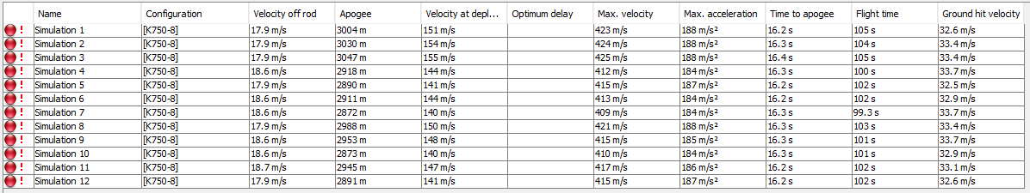

Figure 2 Simulation Results from Fractional Factorial Design

Below is the Actual by Predicted Plot, Figure 3. This figure shows the relationship between the predicated and actual apogee values. The RSq value being nearly one represents that JMP did a great job in creating a system that relates the different factors to its effect on the apogee.

# 

Figure 3 Actual Apogee by Predicted Apogee Plot

The Parameter Estimates are shown below in Figure 4. What this shows is that the Nose cone shape parameter has the biggest affect on its output, which makes sense as the nose cone interacts the most with the atmosphere, usually producing the most drag when not designed correctly. In general, there is not one specific parameter that overpowers all the rest, but some have a larger affect then others.

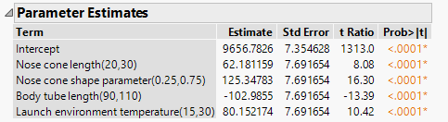

Figure 4 Parameter Estimates for Apogee Prediction

The Prediction Profiler is shown below with the Set Target Desirability enabled. This feature can then be used to predict the values of each to reach a certain height, and in this case, 9,700 feet.

# 

Figure 5 Prediction Profiler with Desirability Function

Shown in Figure 6 are the optimal settings for a Set Target of 9,700 feet. This was done using the Set Target and Desirability function in JMP.



Figure 6 Optimal Results for Rocket Dimensions

# Confirmatory Trials

Three confirmatory trials were performed, and the results of one are shown below. Using the solved parameter from above in OpenRocket, the apogee was calculated to be 9,708 feet, meaning just 8 feet off of the desired value that was inputted into the desirability settings in JMP. That is less than 0.1% off of the desired value.

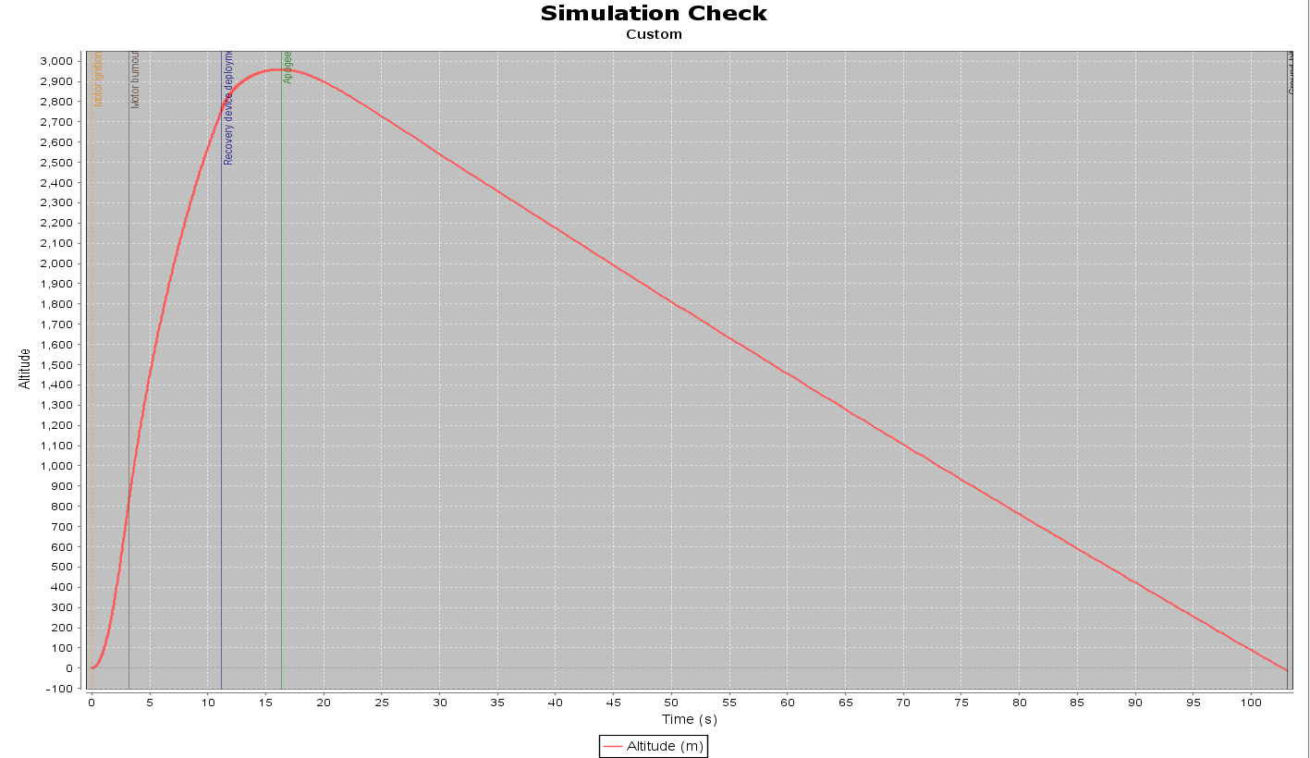

Figure 7 Trial 1

# Conclusion

The optimal settings for the rocket being designed to achieve an apogee of 9,700 feet were as follows; the rocket nose cone length was set to 26.27 cm, the nose cone shape was set to 0.51, the body tube length was set to 95.84 cm and the environmental launch temperature was set to 20.38 degrees Celsius. When put into OpenRocket the apogee simulated was 9,708 feet. This prediction can be trusted after analyzing the Actual by Predicted plot. In the Actual by Predicted plot all the simulations fall within the confidence interval placed on the prediction line. This proves that with collecting data within OpenRocket and calculating the predicted apogee of a specific rocket design and launch conditions, that data can be put into JMP and used to predict what other designs would work to hit a very specific apogee result.